1000 girls

On 26th July, 2017 GetIN mapped its first 1000 pregnant girls since its launch in Kanungu district in November, 2107. Having more girls mapped means more girls giving birth safely at health centers. The biggest number of these girls was age 15-18 followed by 19-21. Getin mobile is a digital tool that was developed to improve the communication between health workers and young pregnant girl so as to ensure that these girls gave birth in health centers with the supervision of a skilled health worker. Also to ensure that these girls attended all the four antenatal visits. This ease after the realization that pregnant girls don’t go for ANC and if they do they only attend one visit and return when it’s time for birth. Others don’t even give birth from hospitals.

Most of these girls have been followed up by the health works using calls provided by getin mobile something that has made follow-up easy and less tiresome or time consuming.

Bataringaya august a chew of rugyeyo sub county says that awareness of danger signs has increased, and these young mothers are fascinated by the phone and feel special when their personal information is put into the system.

Most of the health workers also see the use of this digital tool as a way to advance their knowledge in technology thereby giving them more motivation to map the girls. ‘’I don’t have to worry about losing any information because I know it is stored in the system which is not the case with the vht … we use to follow up the girls, says a chew of Kambuga. He continues to say that holding a smartphone for work makes him feel special and important.

getin can not only be used by midwives and VHTs but also other personnel as lon as they are trained and can interact well with these pregnant girls they can map. A case in point is Didas who works with the inventory of Kihihi health center III but has been trained by the midwives and therefore helps in the mapping incase they’re busy attending to the girls.

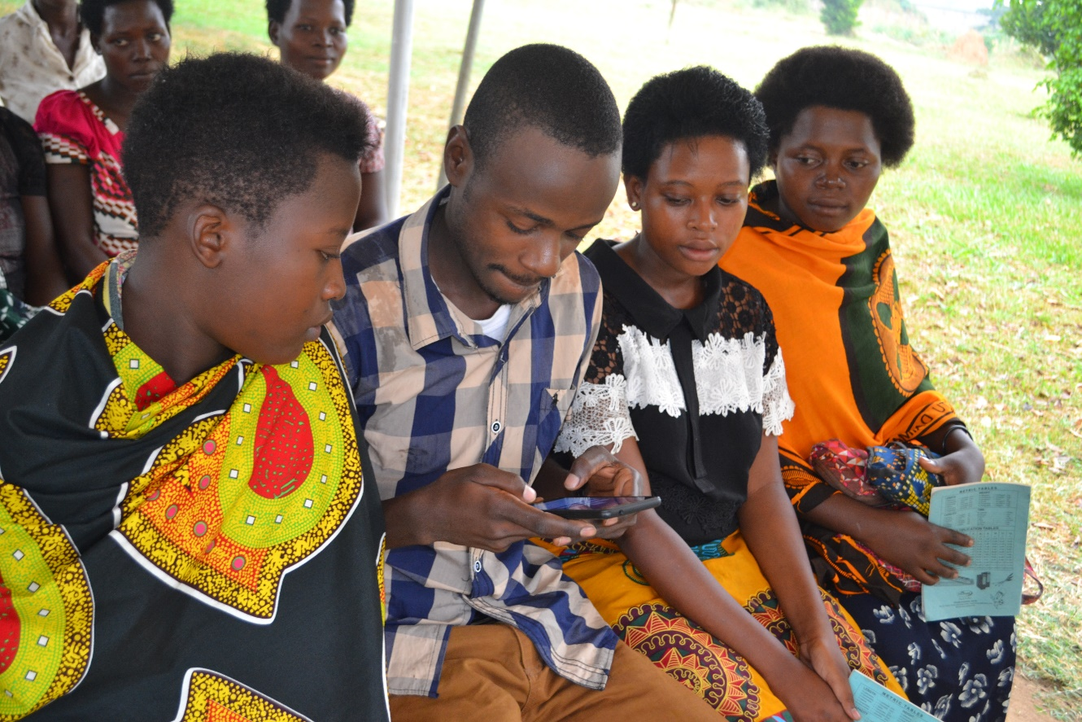

Many of these girls are scared and biased about interacting with heath workers for fear of being judged and insulted but these fears are erased when a midwife calls a girls and genuinely asks about her health and reminds her to come for her antenatal visit.

Some of these girl partners are also being cooperative in the mapping process because they know the risks involved in early pregnancies and are willing to help reduce the likelihood of these risks. For example natukunda patience, 19 years was escorted by her partner for anc and together they sat through the mapping process.

